Delta Modules 2 and 3 – Application Form
Please note that we would prefer an electronic copy of your application emailed to tt@ihkyiv.com
Please state possible dates and time of your oral Zoom interview. Please plan up to 60 mins for it.
__________________________________________________________________________________________________________________________________________

PERSONAL DETAILS
Surname: | Other Names: | Course dates
Address: | Viber phone number:
Address: | Contact Telephone number (if different from above) :
Address: | E-mail address:
Address: | Nationality:
Date of Birth: | Present Occupation & Place of work
First Language:
Zoom skills

EDUCATION AND QUALIFICATIONS
School/College/University | Qualifications Obtained | Dates

Knowledge of Other Languages
Language Approximate Level

Your ELT Experience
Tell us about your teaching since your initial ELT Qualification. Give us an idea of how many years / hours you have taught, and the kind of teaching you have done (levels, groups, 1-2-1, exam preparation, nationalities, different countries and contexts, anything else of note).

Delta Modules 2 and 3 – Pre-course task

Reasons for applying
Please outline briefly why you are interested in the Delta course and how it might benefit you. Try to be specific.
Click or tap here to enter text.

Strengths and weaknesses
Consider what your strengths and weaknesses in relation to the course are. You may consider your experience, previous education/training, language awareness, reading done, teaching techniques, classroom management skills, teacher qualities, personal qualities etc.
Click or tap here to enter text.

Beliefs
Please outline 2 or 3 general principles which underlie your planning and teaching. Include examples of how you apply them in the classroom. Try to refer to a range of levels.
Click or tap here to enter text.

Teaching qualities
Please outline 2 or 3 qualities which you believe make a good teacher.
- Click or tap here to enter text.

Reading
Reading is a significant part of the Delta Modules course. Please describe briefly something, directly related to ELT, you’ve read (book, article, blog etc.) recently. Mention what you found interesting, surprising, useful etc. about it, and why.
Click or tap here to enter text.

Knowledge about language
Please answer the following questions. Try not to refer to any sources, i.e. rely simply on your knowledge. It’s important that we can assess your knowledge accurately to ensure if you’re accepted, you can cope with the course.
1. Provide the term for each definition.
a the use of grammatical and lexical means to achieve connected text, either spoken or written. These include: reference words e.g. this, the, it; linkers e.g. However, and topic-related lexis
Click or tap here to enter text.
b a test employing tasks which replicate real-life activities e.g. role-playing a job interview, writing a letter of complaint, or reading and completing an application form
Click or tap here to enter text.
c a term for an ‘umbrella’ item of lexis which subsumes a range of more specific items
e.g. fruit in relation to apple, orange, pear
Click or tap here to enter text.
d an approach to developing learners’ writing skills that is informed by the belief that creating a written text is purely a matter of imitating elements that are provided in a model
Click or tap here to enter text.

2. Provide a definition and an appropriate brief example or illustration of each of the terms below.
a coordinating conjunction
Click or tap here to enter text.
b modal auxiliary verb
Click or tap here to enter text.
c direct method
Click or tap here to enter text.
d formative assessment
Click or tap here to enter text.

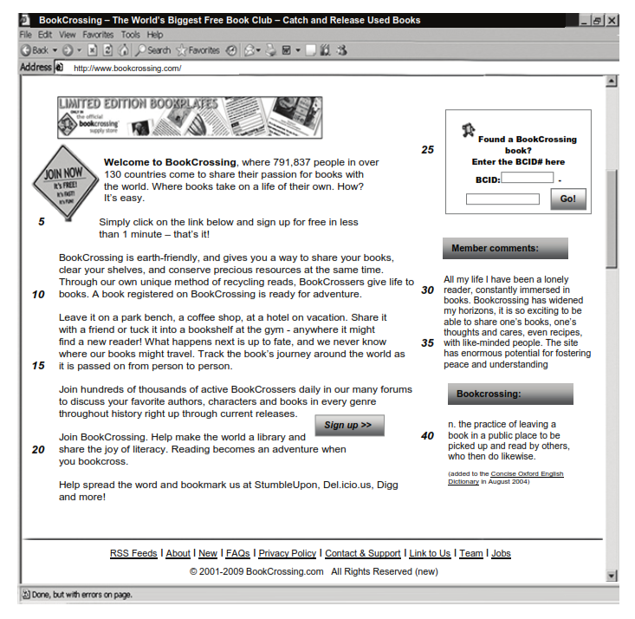
3. Please answer the questions below the text

a Comment on the form and meaning/use of the words in bold as they are used in the text.
i. our unique method of recycling reads (line 9)
Click or tap here to enter text.
ii. Reading becomes an adventure (line 20)
Click or tap here to enter text.
iii. Found a BookCrossing book? (lines 24-25)
Click or tap here to enter text.
b Comment on the use of relative clauses and relative pronouns in the following extracts in the following extracts from the text.
i. Bookcrossing, where 791,837 people in over 130 countries come to share their passion for books (lines 1-2)
Click or tap here to enter text.
c Comment on the features of connected speech likely to occur in the following:
• Used books
• as it is passed on
Click or tap here to enter text.

4. Methodology
What are the advantages and disadvantages of reading aloud in the class? Please outline at least 3 or 4 reasons for and against.
Click or tap here to enter text.

5. Lesson planning
Please use the text from Task 3 to design a 60-minute reading skills lesson for an intermediate level (B1+) class.
Ensure you include:
- brief profile of the group
- main aim and sub-aim
- assumptions
- anticipated problems & solutions
- procedures with stage names, stage aims, procedures, interaction patterns and time allocation
- your tasks

Please submit the LP separately. Include your name in the file name.

6. Rationale
Please write a short rationale (300-400 words) justifying the choices and decisions made while planning the above lesson. Please use continuous prose.
Click or tap here to enter text.

